General information

Team name: Lama

Team members: Andrea Carrarini, 927539

Loris Cerrato, 894173 Polimi

Andrea De Cosmo, 939930

Michele Maione, 931468

__________________________________

# Your “constraints”

Card(s): Three of life and death – Animal house in the forest – Both

Game Genre(s): Action: Shooter – Sport/Simulation: Urban Racing – Both

“Time”: Future

Player mindset: Mid-core

Bartle’s type: Killer

Mode: Multiplayer

__________________________________

Game Design – part 1: concept

Concept: Hypogeum

Logline: Choose your side, race against your opponents and defeat them for the supremacy!

## Introduction

Since humans had left the Earth, centuries have passed and the blue Planet is now inhabited only by the animals, that have learned to manage the technology of our descendants and to create their own. From that moment, a long war among the different species has taken act, to establish which was the best one. Inspired by the ancient books on “mythology”, they decided to set their battles in a huge arena: the Hypogeum. Rather than kill each other in “primitive” ways, they clashed each other using different cars, depending on the species they belong. Now, only four teams have left – Eagles, Lions, Rhinos and Sharks – and the outcome is more uncertain than ever. Who will be the audience’s favorite? Who will win the war? And, most important, who will obtain the supremacy?

## Description (of the game)

In a huge arena, teams of 2 players (where one is the driver and the other is the shooter) face each other in a car-shooting battle.

The goal is to destroy the enemies and to be the last standing species in the battlefield but, to further worsen the situation, the players must pay attention to traps, enemies and unexpected events that may occur.

Even the audience has an important role: randomly or not, it can influence the outcome of the battle, dropping power-ups or maluses that can be collected and used by the teams.

## Key features

The game is based on the synergic collaboration between the players (of same team) that have to face, at the same time, both the environment (traps, obstacles, enemies and unexpected events) and other player that from their part try to kill them.

Depending on the chosen species, each team has its unique skills, weapons, cars and abilities that can use during the battle. Players’ actions may even involve the audience, rising its hype and obtaining rewards or punishments.

Periodically, the different species compete for supremacy and exclusive rewards.

Platform(s): PlayStation 4, Xbox One, PC.

The reason of this choice is related to the player we are targeting and to the genre of our game: a mid-core player, usually, has a console or a computer, whereas an online game requires an Internet connection (that is available on those platforms, thanks to different services). For the same reasons, we have excluded mobile platforms or other consoles (up to now).

Concept Art

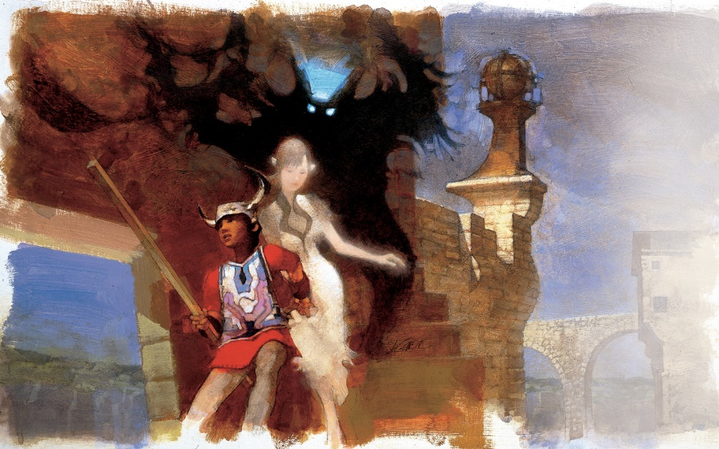(…. Optional FOR CURRENT RELEASE, MUST BE INCLUDED IN THE FINAL RELEASE OF THE CONCEPT!)

Notes

Game Design – part 2: formal and dramatic elements

Try to describe the game you are conceiving in terms of:

## Formal elements

1. Players

Players of the same faction, coupled by a matchmaking system, join a team where each one has its own role (that can be driver or shooter).

Each team can compete against a number of enemy teams that goes from 1 up to 3, in a Team Competition interaction pattern.

1. Objectives

The objective of each battle is to survive to all the other players, traps and unexpected events that may occur.

Moreover, the aim of the whole game is to carry your species to the top and dominate the other ones. For this reason, there is a leaderboard that evaluates both the player’s statistics and the factions’ ranking.

Periodically, in game rewards are given to the best players of each faction, with special prizes to the ones of the best species.

1. Procedures

When the player starts the game, a matchmaking system couples him with another one of the same species and determines their roles.

The game starts with all the teams on their own weaponed car, placed in the arena. One player has to drive the vehicle, paying attention to everything that happens, whereas the other is in charge to shoot the enemies.

Depending on the different faction, a special ability, that charges up with time and players’ performances, can be used.

Being able to perform specific actions will lead to the audience’s involvement, which can drop power-ups or maluses that can be collected by the players.

The match ends up when only one team remains in the arena.

1. Rules

The players have a given role for the whole battle, so they can not change it during the match and can not have both of them.

When the health of the car becomes zero, the team is defeated and the players are taken back to the menu.

When a car is hit by an enemy bullet, its health decreases by an amount of damage that depends on the species’ characteristics. Players can not shoot to themselves.

The special ability of the team can be used only when it is completely charged.

Players’ cars can not leave neither the arena nor the car.

The battle has a time limit, set to prevent stalls. When time’s up, wins the team that has more health left.

The match is won by the team that remains alive at the end of the game or by the one with the highest value of health at the end of the time

1. Resources

Health of the car

Power-ups, health packages and maluses

Time

Traps

Enemies controlled by the computer

1. Conflict

During the matches, players have to face 2 different types of conflict: player-based or environment-based. In the former they fight against other players, whereas in the latter they have to avoid or kill enemies controlled by an artificial intelligence, paying attention to traps and unexpected events that may occur.

In the whole game, players live an external conflict against players of the other factions and an internal one with players of their same species to achieve the top of the 2 leaderboards.

1. Boundaries

The arena has fixed dimensions and can not be left by players.

The matches have a time limit, to prevent stalls.

1. Outcomes

In each match, each team of players gains an amount of point depending on its performances during the battle and, in addiction to this, the winning team gets fixed extra points.

Periodically, in game rewards are given to the best players of each faction, with special prizes to the ones of the best species.

## Dramatic Elements

1. Challenge

There are several types of challenges, from the most individual to the most team-cooperative. Each player has to test his driving and shooting skills and abilities. Moreover, the collaboration between team members is necessary to survive and win the match.

From a more generic point of view, the game continuously challenges the players to work hard to reach the top of the leaderboards, proving to be the best.

1. Play

The game is focused on the players’ abilities and on their desire to prevail on others. It looks evident that it has been designed for players that are extremely competitive (killer players), but it gives possibilities of entertainment also to other types of players (as performers, jokers, socializers or achievers) thanks to a large number of elements such that a huge arena, random events, collaboration with others and audience involvement that can influence the gameplay.

1. Premise

Since humans had left the Earth, centuries have passed and the blue Planet is now inhabited only by the animals, that have learned to manage the technology of our descendants and to create their own. From that moment, a long war among the different species has taken act, to establish which was the best one. Inspired by the ancient books on “mythology”, they decided to set their battles in a huge arena: the Hypogeum. Rather than kill each other in “primitive” ways, they clashed each other using different cars, depending on the species they belong. Now, only four teams have left – Eagles, Lions, Rhinos and Sharks – and the outcome is more uncertain than ever.

1. Character(s)

The game, to represent players, uses characters each one representative of one of the factions that compete in the game. The player can choose his side among 4 different animal species (each one with its own skills and characteristics) based on his playstyle, preferred animal or on which is the one he feels more connected to. The possible factions are Eagles, Lions, Rhinos and Sharks but their characterization and story are still work in progress.

1. Story

In a remote future, humans have finally abandoned the Earth to move on an exoplanet (a planet outside the solar system) where the mankind would find the suitable conditions to live. After this, only the animals were left on the blue planet.

Over centuries, those creatures have evolved and have learnt to use all the technology humans have left and to communicate and act as men, ending up acquiring part of our descendants’ anatomy.

Four species have risen above the others - Eagles, Lions, Rhinos and Sharks – and started a long war that has lasted for decades, causing thousands of deaths to the point of risking the extinction. Aware that the conflict would lead to nothing different from pain and destruction, the chiefs of the factions decided to reach an agreement: the war had to stop and their clash to get the supremacy would have been set only in the Hypogeum, a huge arena where couples of the best individuals of each species would have driven cars equipped with different weapons, trying to kill each other and to .

Due to the actual idea and nature of the game, from this point on there is not a well-defined story up to now. One of the possible alternatives is to represent a series of events set during the conflict that involves the 4 species.